Additional assistant referees to continue
Published: Thursday 12 July 2012, 15.30CET
Additional assistant referees will continue to be used in the forthcoming UEFA club competition season, following last week's decision by the International Football Association Board (IFAB).

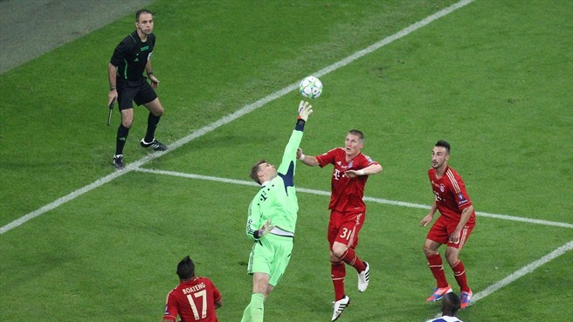
Additional assistant referees were deployed in the 2012 UEFA Champions League final ©Domenic Aquilina
UEFA has decided to continue with the use of additional assistant referees as from the play-off matches of the 2012/13 UEFA Champions League, the group stage of the 2012/13 UEFA Europa League and the 2012 UEFA Super Cup.
This follows the International Football Association Board's (IFAB) unanimous decision on 5 July 2012 to amend the Laws of the Game and allow the use of such extra officials, acknowledging the support they can provide in officiating matches, following the successful trials that were conducted in various competitions over the last few years.
As part of the experiment, six match officials were officiating at games – the referee, two assistants and fourth official were joined by two additional assistant referees positioned alongside each goal, with the particular brief to watch for penalty-area incidents.
The experiment was initiated in selected UEFA European Under-19 youth qualifying tournaments in 2008. It was then implemented at all 144 matches in the group stage of the 2009/10 UEFA Europa League as well as in the subsequent knockout matches up to and including the final.
Following a decision by IFAB in July 2010, the trial continued at matches in the UEFA Champions League and UEFA Europa League in the 2010/11 and 2011/12 seasons. It was also deployed at the UEFA Super Cup in 2011, and additional assistants were used at UEFA EURO 2012.
In essence, the additional assistant referees provide two extra pairs of eyes to monitor the game and ensure that the Laws of the Game are upheld. They inform the referee of incidents of any kind that he may otherwise have missed, particularly in key areas of the field like the penalty area and its surroundings. The referee will remain in sole charge of the match, and the only match official with decision-making powers.

